RENDEZVOUS 2015
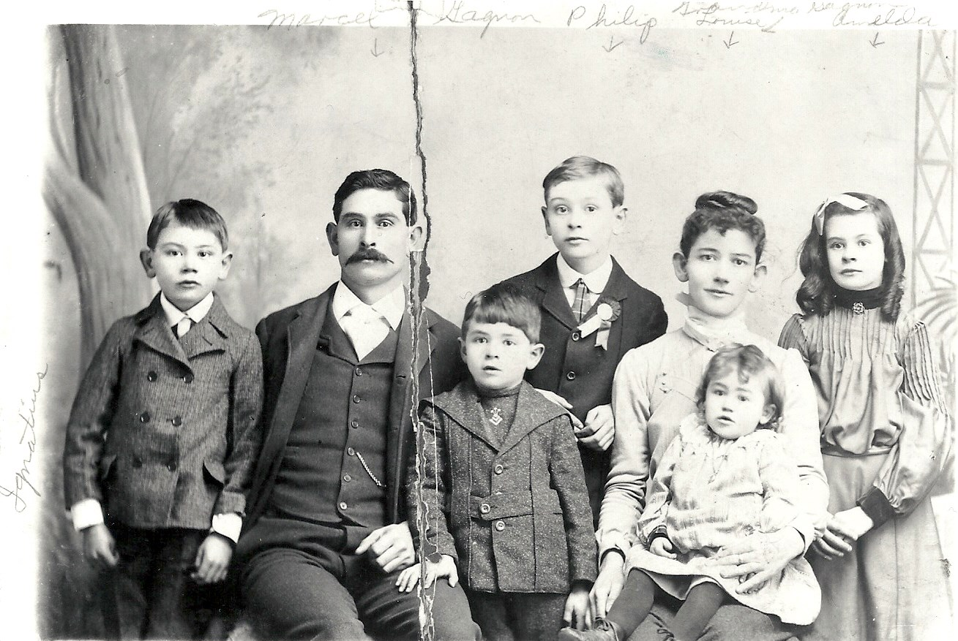
FRENCHTOWN FAMILY ALBUM
This year’s Rendezvous stars the Frenchtown families themselves. We invite all attendees to bring pictures and stories of their family’s history in the area to share with others, others who may even be cousins! We will be making a special effort to invite descendants from out of town to come and share their precious memories. Tables will be set up for sharing from 1-3:30 pm. We will have a station for Ancestry.com, and information about how to research and preserve your family history.
Marcel Gagnon Jr. & Louisa Remillard family
Rendezvous tickets are $30 per adult and include a tri-tip dinner, living history presentations, music, historical displays, a raffle and a silent auction. Wine and beer by the glass are available for purchase. Raffle tickets are $5 each. This year’s raffle prizes are a hot air balloon ride for two and a Wildhorse Resort & Casino room stay with a $100.00 food voucher. Raffle winners need not be present to win.
Tickets are available from Judith Fortney 509-529-8210, frenchtownpartners@charter.net, or from any Frenchtown Historical Foundation board member. If you have questions about the tables for sharing your family documents, contact Sarah Hurlburt, hurlbuse@whitman.edu.
WHY SUPPORT THE FRENCHTOWN HISTORICAL FOUNDATION?
The Rendezvous is the principal fundraiser for the maintenance and development of the Frenchtown Historic site. This year, our goals are threefold:
- Expand our educational mission and raise public awareness of Frenchtown in the community at large.
- Raise capital for a cedar shake roof for the Prince’s cabin.
- Create an endowment fund with the Blue Mountain Community Foundation for the physical maintenance of the site, signage, and shelters.
Located approximately 8 miles west of Walla Walla on old Highway 12, the Frenchtown Historic Site is free and open to the public from dawn to dusk. The site includes trails and interpretive signage and the oldest existing log cabin in the state of Washington. A log shelter in the style of French Canadian cabins provides covered space for gatherings and presentations, equipment storage, restrooms and displays.
For more information about the Frenchtown Historic site or the Frenchtown Historical Foundation, please visit our website at www.frenchtownpartners.org, email frenchtownpartners@charter.net or call 509-522-3763.

