History for Genealogists
How to use historical societies
Please join us for this great presentation by
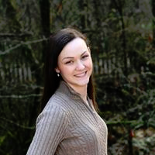 HANNAH ALLAN, A byu FAMILY HISTORY AND GENEALOGY GRADUATE, AND CURRENTLY ON SITE GENEALOGIST FOR THE OREGON HISTORICAL SOCIETY IN PORTLAND, AMONG MANY OTHER PAST AND CURRENT GENEALOGY RELATED ACTIVITIES.

LOWER COLUMBIA GENEALOGICAL SOCIETy
http://www.rootsweb.ancestry.com/~walcolgs/

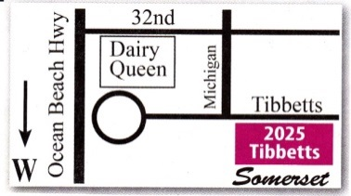
SOMERSET RETIREMENT APARTMENTS
2025 TIBBETTS DRIVE, LONGVIEW
DINING ROOM 7:00 PM
Feb 9, 2017

VISITORS ARE WELCOME AND ENCOURAGED TO ATTEND.

